Sponsor Capstone Project Proposal Form

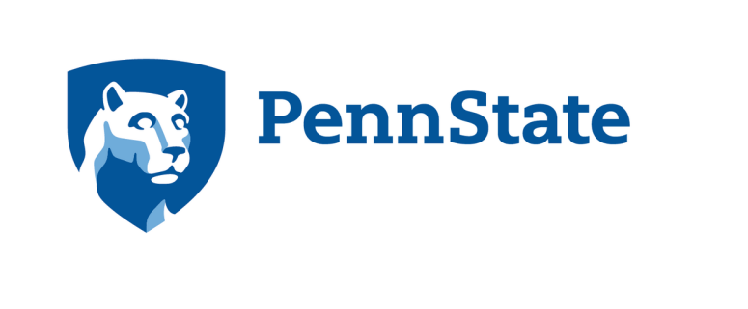

B.S. Engineering

Multidisciplinary Engineering Design

Capstone Project Proposal

Capstone Project Sponsorship Acknowledgement

Thank you for your interest in supporting student projects for the B.S. Engineering program, Multidisciplinary Engineering Design (MDE). As a result of your support and involvement, undergraduate students at The Pennsylvania State University (the "University") working through the MDE program will be engaged on a project based on your input and support. Real world projects such as the one you are supporting significantly enhance student learning experiences. In return for your support and participation, the University will provide you with a copy of the project results, including as appropriate, any data, analysis, hardware and/or software (the "Student Project Results"), provided you agree with and acknowledge the following terms.
1. Student Project Results provided shall be used solely for your own internal review and analysis. Any and all rights to the Student Project Results, including all Intellectual Property Rights, if any, shall remain the rights of the individual student participants as appropriate under the law regarding rights to and ownership of intellectual property unless there is a separate written agreement addressing the ownership of intellectual property. Prior to any commercial use or subsequent transfer of any Student Project Results, you must obtain the appropriate rights from the respective owners.
I Agree
2. STUDENT PROJECT RESULTS ARE PROVIDED "AS IS" WITHOUT ANY REPRESENTATION OR WARRANTIES WHATSOEVER, WHETHER EXPRESS OR IMPLIED, INCLUDING, BUT NOT NECESSARILY LIMITED TO ANY WARRANTY AS TO FITNESS FOR PARTICULAR PURPOSES, MERCHANTABILITY OR NON-INFRINGEGEENT. All student projects are performed by University students and are not subject to peer review or independent verification of results. You hereby agree to indemnify and hold harmless University, its agents, employees, students and volunteers for any and all harm, loss, liability, claims or damages which may arise from your use of the Student Project Results in whatever manner or form.
I Agree
3. The Student Project Results are not the work of the University and any references either internally or to third parties shall clearly identify the source of the Student Project Results as an undergraduate student project performed at the University without subsequent independent evaluation. Publication of any aspect of the Student Project Results must be approved in writing by the author(s) and must contain appropriate references as to the source and development of the published information.
I Agree
4. The deduction to which you may be entitled as a result of your support is limited to the excess of the amount of your contribution to the University over the value of goods or services provided to you by the University. If you do not request ownership of intellectual property developed during the course of the project, the University has determined that the value of the goods and services furnished to you is $1000. If you request ownership of intellectual property developed during the course of the project, the University has determined that the value of the goods and services furnished to you is $1500. Please note that your deduction for the balance of the contribution may be further limited under applicable law. Please consult your tax advisor.
I Agree
Budget:
A donation of $3,000 is required for the first project team. Because this is a charitable contribution, no guarantees can be made on project outcomes, other than "Best Effort". Students are provided a working budget of $1,000 to cover direct expenses for materials, supplies, and travel required for completion of the project. The remainder covers overhead expenses of the participating departments and their facilities (public events, supplies, equipment replacement, etc.). Additional funds may be required from the sponsor for specialized equipment, other unique project expenses, or for intellectual property ownership rights (as noted below).
I agree to accept project fee(s)

Sponsor Project Submission Form
Proprietary and company confidential information should not be disclosed on this form. For information on what constitutes an attractive capstone project, refer to the document “E-MDE Capstone Sponsor Guidelines”

Contact Information

Company Name
Address
Project Contact
Contact Phone
Contact Email
Mentor
Mentor Phone
Mentor Email
Project Information

Project Title
Project Objective(s)
Project Description
Please Provide a descriptive, enticing ½-1 page intro to the project ideally with pictures/figures sufficient for student teams to know what the problem they are to solve and what type of solution is appropriate. This information will be used to match student teams to projects, after which they will contact the project Mentor.
Project Deliverables
Funding (specify additional sources of funding)

Intellectual Property and Confidentiality Requirements

These NON-NEGOTIABLE agreements were specifically designed for capstone design projects and most recently updated July 2016. We are unable to entertain company-provided agreements and the students cannot sign company-provided agreements.

IMPORTANT! The IP and Confidentiality agreements must be requested upon project submission. The capstone students take these into consideration when selecting projects that are of interest to them. If a student is not willing to sign either of these agreements, they must select a project that does not have either of these agreement requirements.

Confidentiality for sponsor-provided information: The PSU non disclsosure agreement will be provided upon request(and is included in the Capstone Project Guideline Document). The terms in the agreement are not negotiable, including the two-year expiration date. An additional donation of $500 is required to support the administrative processing a Non-Disclosure Agreement with the team once it is formed.
Yes, I would like to request the confidentiality (Non-disclosure) agreement for sponsor-provided information
No, my project does not require the confidentiality agreement

Intellectual Property (IP) ownership rights retained by sponsor: The intellectual Property ownership rights form is available upon request (and is provided in the Capstone Project Guidelines Document). The terms in this form are not negotiable. An additional donation of $500 is required to support administrative processing of an Intellectual Property Agreement with the team once it is formed.
Yes, I would like to request the intellectual property ownership rights retained by sponsor
No, my project does not require the intellectual property agreement

This Sponsor Capstone Project Proposal Submission Form should be submitted via email to:

Douglas B. Schumer, Ph.D., Associate Professor of Engineering Design
(Office) 610-648-3355 dbs5376@psu.edu (Mobile) 404-918-3630

